МІНІСТЕРСТВО ОСВІТИ І НАУКИ УКРАЇНИ

ДЕРЖАВНИЙ УНІВЕРСИТЕТ «ОДЕСЬКА ПОЛІТЕХНІКА»

ІНСТИТУТ КОМП’ЮТЕРНИХ СИСТЕМ

КАФЕДРА ІЖЕНЕРІЇ ПРОГРАМНОГО ЗАБЕЗПЕЧЕННЯ

Протокол лабораторної роботи №6

З дисципліни «Основи програмування»

на тему:

«Створення ігрової програми засобами бібліотеки Pygame»

Варіант 23

Виконав студент групи АС-211:

Пасека Ілля Вікторович

Перевірила:

д. Комлева Н.О.

Одеса 2021

**Зміст**

Завдання..................................................................................................................3

Код …....................................................................................................................3-7

Робота програми......................................................................................................7

Висновоки................................................................................................................7

**Завдання**

Необхідно придумати концепцію гри та створити ігрову програму за власними принципами та алгоритмом роботи з використанням спрайтів, можливостей руху спрайтів, налаштування кольорів та ін. Як основу взяти шаблон для ігрового проекту .

**Код**

**Файл main:**

import pygame

import math

from settings import *

from classes import Player

from classes import Zombie

def signum(x):

    return 1 if (x > 0) else -1 if (x < 0) else 0

pygame.init()

sc = pygame.display.set_mode((Screen_height, Screen_widht), pygame.DOUBLEBUF | pygame.HWSURFACE)

pygame.display.set_caption(" Shooter ")

pygame.mixer.music.load("Hell on Earth.mp3")

pygame.mixer.music.play(-1)

clock = pygame.time.Clock()

player = Player()

wall_1 = pygame.image.load("block.jpg")

wall_1_rect = wall_1.get_rect(center = (200, 200))

wall_2 = pygame.image.load("block.jpg")

wall_2_rect = wall_2.get_rect(center = (1000, 200))

wall_3 = pygame.image.load("block.jpg")

wall_3_rect = wall_3.get_rect(center = (200, 600))

wall_4 = pygame.image.load("block.jpg")

wall_4_rect = wall_3.get_rect(center = (1000, 600))

wall_5 = pygame.image.load("block.jpg")

wall_5_rect = wall_3.get_rect(center = (600, 400))

bullets = []

zomb_spawn = (((0,1366), (-800,-400)),

              ((0,1366), (1200,1600)),

              ((-800,-400), (0,800)),

              ((1766,2166), (0,800)))

zomb_spawn_sec = random.randint(0, 3)

zombies = [Zombie(random.randint(zomb_spawn[zomb_spawn_sec][0][0], zomb_spawn[zomb_spawn_sec][0][1]),

                  random.randint(zomb_spawn[zomb_spawn_sec][1][0], zomb_spawn[zomb_spawn_sec][1][1]),

                  zombie_speed) for i in range(zombie_count)]

while Running_flag:

    for event in pygame.event.get():

        if event.type == pygame.QUIT:

            Running_flag = False

    sc.fill("darkgrey")

    sold_surf = pygame.image.load("soldier.png")

    sold_rect = sold_surf.get_rect(center=player.pos)

    sold_surf = pygame.transform.rotate(sold_surf, player.sold_angle)

    sc.blit(wall_1, wall_1_rect)

    sc.blit(wall_2, wall_2_rect)

    sc.blit(wall_3, wall_3_rect)

    sc.blit(wall_4, wall_4_rect)

    sc.blit(wall_5, wall_5_rect)

    sc.blit(sold_surf, sold_rect)

    # sc.blit(zomb_surf, zomb_rect)

    for zomb in zombies:

        rot = pygame.transform.rotate(zomb.zomb_surf, math.degrees(zomb.angle))

        sc.blit(rot, zomb.zomb_rect)

    #pygame.draw.circle(sc, "green" ,player.pos, 16)

    #pygame.draw.line(sc, "green", player.pos, (player.x + height * math.cos(player.angle),

                                                                           # player.y + height* math.sin(player.angle)))

    for bullet in bullets:

        bullet.update()

    for bullet in bullets:

        bullet.draw(sc)

    for bullet in bullets:

        if bullet.rect.centerx < 0 or bullet.rect.centerx > 1366 or \

                bullet.rect.centery < 0 or bullet.rect.centery > 768:

            bullets.remove(bullet)

        if wall_1_rect.colliderect(bullet.rect):

            bullets.remove(bullet)

        if wall_2_rect.colliderect(bullet.rect):

            bullets.remove(bullet)

        if wall_3_rect.colliderect(bullet.rect):

            bullets.remove(bullet)

        if wall_4_rect.colliderect(bullet.rect):

            bullets.remove(bullet)

        if wall_5_rect.colliderect(bullet.rect):

            bullets.remove(bullet)

    for zomb in zombies:

        for bullet in bullets:

            if zomb.zomb_rect.colliderect(bullet.rect):

                bullets.remove(bullet)

                zomb.health = zomb.health - b_damage

                print(zomb.health)

                if zomb.health <= 0:

                    print("zombie killed")

                    killed_zombies+=1

                    zombies.remove(zomb)

                    break

    for zomb in zombies:

        if zomb.zomb_rect.colliderect(sold_rect):

            soldier_hp= soldier_hp-zombie_aim

            print (soldier_hp)

            if soldier_hp <=0 :

                print("YOU WAS KILLED, TRY AGAIN")

                Running_flag = False

                break

    for zomb in zombies :

        zomb.zomb_update(player.pos)

        print(zomb.angle, math.degrees(zomb.angle))

    f = pygame.font.SysFont(None, 24)

    sc_text= f.render("HP: ", 1, "red")

    sc_text_rect= sc_text.get_rect(center=(Screen_height//2, 10))

    sc.blit(sc_text, sc_text_rect)

    f1 = pygame.font.SysFont(None, 24)

    sc_text1= f1.render(str(int(soldier_hp)), 1, "red")

    sc_text_rect1= sc_text1.get_rect(center=(Screen_height//2+27, 10))

    sc.blit(sc_text1, sc_text_rect1)

    f2 = pygame.font.SysFont(None, 24)

    sc_text2= f2.render("Killled zombies:", 1, "blue")

    sc_text_rect2= sc_text2.get_rect(center=(Screen_height//2, 760))

    sc.blit(sc_text2, sc_text_rect2)

    f3 = pygame.font.SysFont(None, 24)

    sc_text3= f3.render(str(killed_zombies), 1, "blue")

    sc_text_rect3= sc_text3.get_rect(center=(Screen_height//2+78, 760))

    sc.blit(sc_text3, sc_text_rect3)

    # debug

    #pygame.draw.circle(sc, (0, 255, 0), (sold_rect.centerx, sold_rect.centery), 1)

    #pygame.draw.circle(sc, (0, 255, 0), (wall_1_rect.centerx, wall_1_rect.centery), 1)

    #pygame.draw.line(sc, (0, 255, 0),

    #                 (sold_rect.centerx, sold_rect.centery),

    #                 (wall_1_rect.centerx, wall_1_rect.centery), 2)

    #pygame.draw.line(sc, (0, 0, 255),

    #                 (sold_rect.centerx, sold_rect.centery - signum(sold_rect.centery - wall_1_rect.centery) * sold_rect.height / 2),

    #                 (wall_1_rect.centerx, wall_1_rect.centery), 2)

    #pygame.draw.line(sc, (0, 0, 255),

    #                 (sold_rect.centerx - signum(sold_rect.centerx - wall_1_rect.centerx) * sold_rect.width / 2, sold_rect.centery),

    #                 (wall_1_rect.centerx, wall_1_rect.centery), 2)

    ##

    if len(zombies) == 0:

        if player.delay > 3:

            player.delay -= 1

        if zombie_speed <= 4:

            zombie_speed += 1

        if zombie_count <= 50:

            zombie_count += 4

        zomb_spawn_sec = random.randint(0, 3)

        zombies = [Zombie(random.randint(zomb_spawn[zomb_spawn_sec][0][0], zomb_spawn[zomb_spawn_sec][0][1]),

                          random.randint(zomb_spawn[zomb_spawn_sec][1][0], zomb_spawn[zomb_spawn_sec][1][1]),

                          zombie_speed) for i in range(zombie_count)]

    for zomb in zombies:

        if wall_1_rect.colliderect(zomb.zomb_rect):

            pos = [zomb.zomb_rect.centerx - wall_1_rect.centerx, zomb.zomb_rect.centery - wall_1_rect.centery]

            if (abs(pos[0]) / (wall_1_rect.width / 2)) > (abs(pos[1]) / (wall_1_rect.height / 2)):

                pos[0] = signum(pos[0])

                pos[1] = 0

                zomb.pos[0] += zombie_speed * pos[0]

            if (abs(pos[0]) / (wall_1_rect.width / 2)) < (abs(pos[1]) / (wall_1_rect.height / 2)):

                pos[1] = signum(pos[1])

                pos[0] = 0

                zomb.pos[1] += zombie_speed * pos[1]

        if wall_2_rect.colliderect(zomb.zomb_rect):

            pos = [zomb.zomb_rect.centerx - wall_2_rect.centerx, zomb.zomb_rect.centery - wall_2_rect.centery]

            if (abs(pos[0]) / (wall_2_rect.width / 2)) > (abs(pos[1]) / (wall_2_rect.height / 2)):

                pos[0] = signum(pos[0])

                pos[1] = 0

                zomb.pos[0] += zombie_speed * pos[0]

            if (abs(pos[0]) / (wall_2_rect.width / 2)) < (abs(pos[1]) / (wall_2_rect.height / 2)):

                pos[1] = signum(pos[1])

                pos[0] = 0

                zomb.pos[1] += zombie_speed * pos[1]

        if wall_3_rect.colliderect(zomb.zomb_rect):

            pos = [zomb.zomb_rect.centerx - wall_3_rect.centerx, zomb.zomb_rect.centery - wall_3_rect.centery]

            if (abs(pos[0]) / (wall_3_rect.width / 2)) > (abs(pos[1]) / (wall_3_rect.height / 2)):

                pos[0] = signum(pos[0])

                pos[1] = 0

                zomb.pos[0] += zombie_speed * pos[0]

            if (abs(pos[0]) / (wall_3_rect.width / 2)) < (abs(pos[1]) / (wall_3_rect.height / 2)):

                pos[1] = signum(pos[1])

                pos[0] = 0

                zomb.pos[1] += zombie_speed * pos[1]

        if wall_4_rect.colliderect(zomb.zomb_rect):

            pos = [zomb.zomb_rect.centerx - wall_4_rect.centerx, zomb.zomb_rect.centery - wall_4_rect.centery]

            if (abs(pos[0]) / (wall_4_rect.width / 2)) > (abs(pos[1]) / (wall_4_rect.height / 2)):

                pos[0] = signum(pos[0])

                pos[1] = 0

                zomb.pos[0] += zombie_speed * pos[0]

            if (abs(pos[0]) / (wall_4_rect.width / 2)) < (abs(pos[1]) / (wall_4_rect.height / 2)):

                pos[1] = signum(pos[1])

                pos[0] = 0

                zomb.pos[1] += zombie_speed * pos[1]

        if wall_5_rect.colliderect(zomb.zomb_rect):

            pos = [zomb.zomb_rect.centerx - wall_5_rect.centerx, zomb.zomb_rect.centery - wall_5_rect.centery]

            if (abs(pos[0]) / (wall_5_rect.width / 2)) > (abs(pos[1]) / (wall_5_rect.height / 2)):

                pos[0] = signum(pos[0])

                pos[1] = 0

                zomb.pos[0] += zombie_speed * pos[0]

            if (abs(pos[0]) / (wall_5_rect.width / 2)) < (abs(pos[1]) / (wall_5_rect.height / 2)):

                pos[1] = signum(pos[1])

                pos[0] = 0

                zomb.pos[1] += zombie_speed * pos[1]

    if wall_1_rect.colliderect(sold_rect):

        temp_pos = [sold_rect.centerx - wall_1_rect.centerx, sold_rect.centery - wall_1_rect.centery]

        if (abs(temp_pos[0]) / (wall_1_rect.width / 2)) > (abs(temp_pos[1]) / (wall_1_rect.height / 2)):

            temp_pos[0] = signum(temp_pos[0])

            temp_pos[1] = 0

            player.x += player_speed * temp_pos[0]

        if (abs(temp_pos[0]) / (wall_1_rect.width / 2)) < (abs(temp_pos[1]) / (wall_1_rect.height / 2)):

            temp_pos[1] = signum(temp_pos[1])

            temp_pos[0] = 0

            player.y += player_speed * temp_pos[1]

    if wall_2_rect.colliderect(sold_rect):

        temp_pos = [sold_rect.centerx - wall_2_rect.centerx, sold_rect.centery - wall_2_rect.centery]

        if (abs(temp_pos[0]) / (wall_2_rect.width / 2)) > (abs(temp_pos[1]) / (wall_2_rect.height / 2)):

            temp_pos[0] = signum(temp_pos[0])

            temp_pos[1] = 0

            player.x += player_speed * temp_pos[0]

        if (abs(temp_pos[0]) / (wall_2_rect.width / 2)) < (abs(temp_pos[1]) / (wall_2_rect.height / 2)):

            temp_pos[1] = signum(temp_pos[1])

            temp_pos[0] = 0

            player.y += player_speed * temp_pos[1]

    if wall_3_rect.colliderect(sold_rect):

        temp_pos = [sold_rect.centerx - wall_3_rect.centerx, sold_rect.centery - wall_3_rect.centery]

        if (abs(temp_pos[0]) / (wall_3_rect.width / 2)) > (abs(temp_pos[1]) / (wall_3_rect.height / 2)):

            temp_pos[0] = signum(temp_pos[0])

            temp_pos[1] = 0

            player.x += player_speed * temp_pos[0]

        if (abs(temp_pos[0]) / (wall_3_rect.width / 2)) < (abs(temp_pos[1]) / (wall_3_rect.height / 2)):

            temp_pos[1] = signum(temp_pos[1])

            temp_pos[0] = 0

            player.y += player_speed * temp_pos[1]

    if wall_4_rect.colliderect(sold_rect):

        temp_pos = [sold_rect.centerx - wall_4_rect.centerx, sold_rect.centery - wall_4_rect.centery]

        if (abs(temp_pos[0]) / (wall_4_rect.width / 2)) > (abs(temp_pos[1]) / (wall_4_rect.height / 2)):

            temp_pos[0] = signum(temp_pos[0])

            temp_pos[1] = 0

            player.x += player_speed * temp_pos[0]

        if (abs(temp_pos[0]) / (wall_4_rect.width / 2)) < (abs(temp_pos[1]) / (wall_4_rect.height / 2)):

            temp_pos[1] = signum(temp_pos[1])

            temp_pos[0] = 0

            player.y += player_speed * temp_pos[1]

    if wall_5_rect.colliderect(sold_rect):

        temp_pos = [sold_rect.centerx - wall_5_rect.centerx, sold_rect.centery - wall_5_rect.centery]

        if (abs(temp_pos[0]) / (wall_5_rect.width / 2)) > (abs(temp_pos[1]) / (wall_5_rect.height / 2)):

            temp_pos[0] = signum(temp_pos[0])

            temp_pos[1] = 0

            player.x += player_speed * temp_pos[0]

        if (abs(temp_pos[0]) / (wall_5_rect.width / 2)) < (abs(temp_pos[1]) / (wall_5_rect.height / 2)):

            temp_pos[1] = signum(temp_pos[1])

            temp_pos[0] = 0

            player.y += player_speed * temp_pos[1]

    player.movement(bullets)

    pygame.display.update()

    clock.tick(FPS)

pygame.quit()

**Файл classes:**

from settings import *

import pygame

import math

import time

class Bullet:

    def __init__(self, bullet_angle, start_pos):

        self.coords = start_pos

        self.angle = bullet_angle

        self.image = pygame.image.load("e4b.png").convert_alpha()

        self.rect = self.image.get_rect(center = self.coords)

    def update(self):

        self.coords[0] += bullet_speed * math.cos(self.angle)

        self.coords[1] += bullet_speed * math.sin(self.angle)

        self.rect.centerx = self.coords[0]

        self.rect.centery = self.coords[1]

    def draw(self, screen):

        screen.blit(self.image, self.rect)

class Zombie:

    def __init__(self, posx, posy, speed):

        self.pos = [posx, posy]

        self.zomb_surf = pygame.image.load("zombie.png")

        self.zomb_rect = self.zomb_surf.get_rect(center=[self.pos[0], self.pos[1]])

        self.health = 100

        self.speed = speed

        self.angle = 0

    def zomb_update(self, sold_pos):

        self.angle = math.atan2(self.pos[0] - sold_pos[0], self.pos[1] - sold_pos[1]) + math.pi/2

        self.pos[0] += math.cos(self.angle) * self.speed

        self.pos[1] -= math.sin(self.angle) * self.speed

        self.zomb_rect.centerx = self.pos[0]

        self.zomb_rect.centery = self.pos[1]

        return self.pos

class Player:

    def __init__(self):

        self.x = player_x

        self.y = player_y

        self.angle = player_angle

        self.sold_angle = sol_angle

        self.counter = 0

        self.delay = player_delay

    @property

    def pos(self):

        return self.x, self.y

    def movement(self, bullets):

        sin_a = math.sin(self.angle)

        cos_a = math.cos(self.angle)

        keys = pygame.key.get_pressed()

        if keys[pygame.K_w]:

            self.y -= player_speed

            if self.y < 0:

                self.y = 0

        if keys[pygame.K_s]:

            self.y += player_speed

            if self.y > 768:

                self.y = 768

        if keys[pygame.K_a]:

            self.x -= player_speed

            if self.x < 0:

                self.x = 0

        if keys[pygame.K_d]:

            self.x += player_speed

            if self.x > 1366:

                self.x = 1366

        if keys[pygame.K_LEFT]:

            self.sold_angle += 4

            self.angle -= 0.06981317008

        if keys[pygame.K_RIGHT]:

            self.sold_angle -= 4

            self.angle += 0.06981317008

        if keys[pygame.K_SPACE]:

            self.shoot(bullets)

    def shoot(self, bullets):

        if self.counter % self.delay == 0:

            bullets.append(Bullet(self.angle, [self.x + height * math.cos(self.angle),

                                               self.y + height * math.sin(self.angle)]))

        self.counter += 1

        self.counter %= FPS

**Файл settings:**

import math

import random

Running_flag = True

FPS=60

Screen_height = 1366

Screen_widht = 768

#player position

player_x =  700

player_y =  700

player_speed = 4

player_angle = 0

height = 30

# bullet

bullet_speed = 10

scatter = random.random()*(0.1745329252+0.1745329252)-0.1745329252

#soldier

sol_angle = 0

soldier_hp=100

zombie_aim=0.03

player_delay=6

#ZOMBIE

zombie_start_pos= (400, 400)

b_damage=50

zombie_angle=0

zombie_health=100

killed_zombies=0

zombie_speed=2

zombie_count=10

**Приклад викоонання програми:**

Приклад виконання лабораторної роботи див. у відео

Sequence Diagram

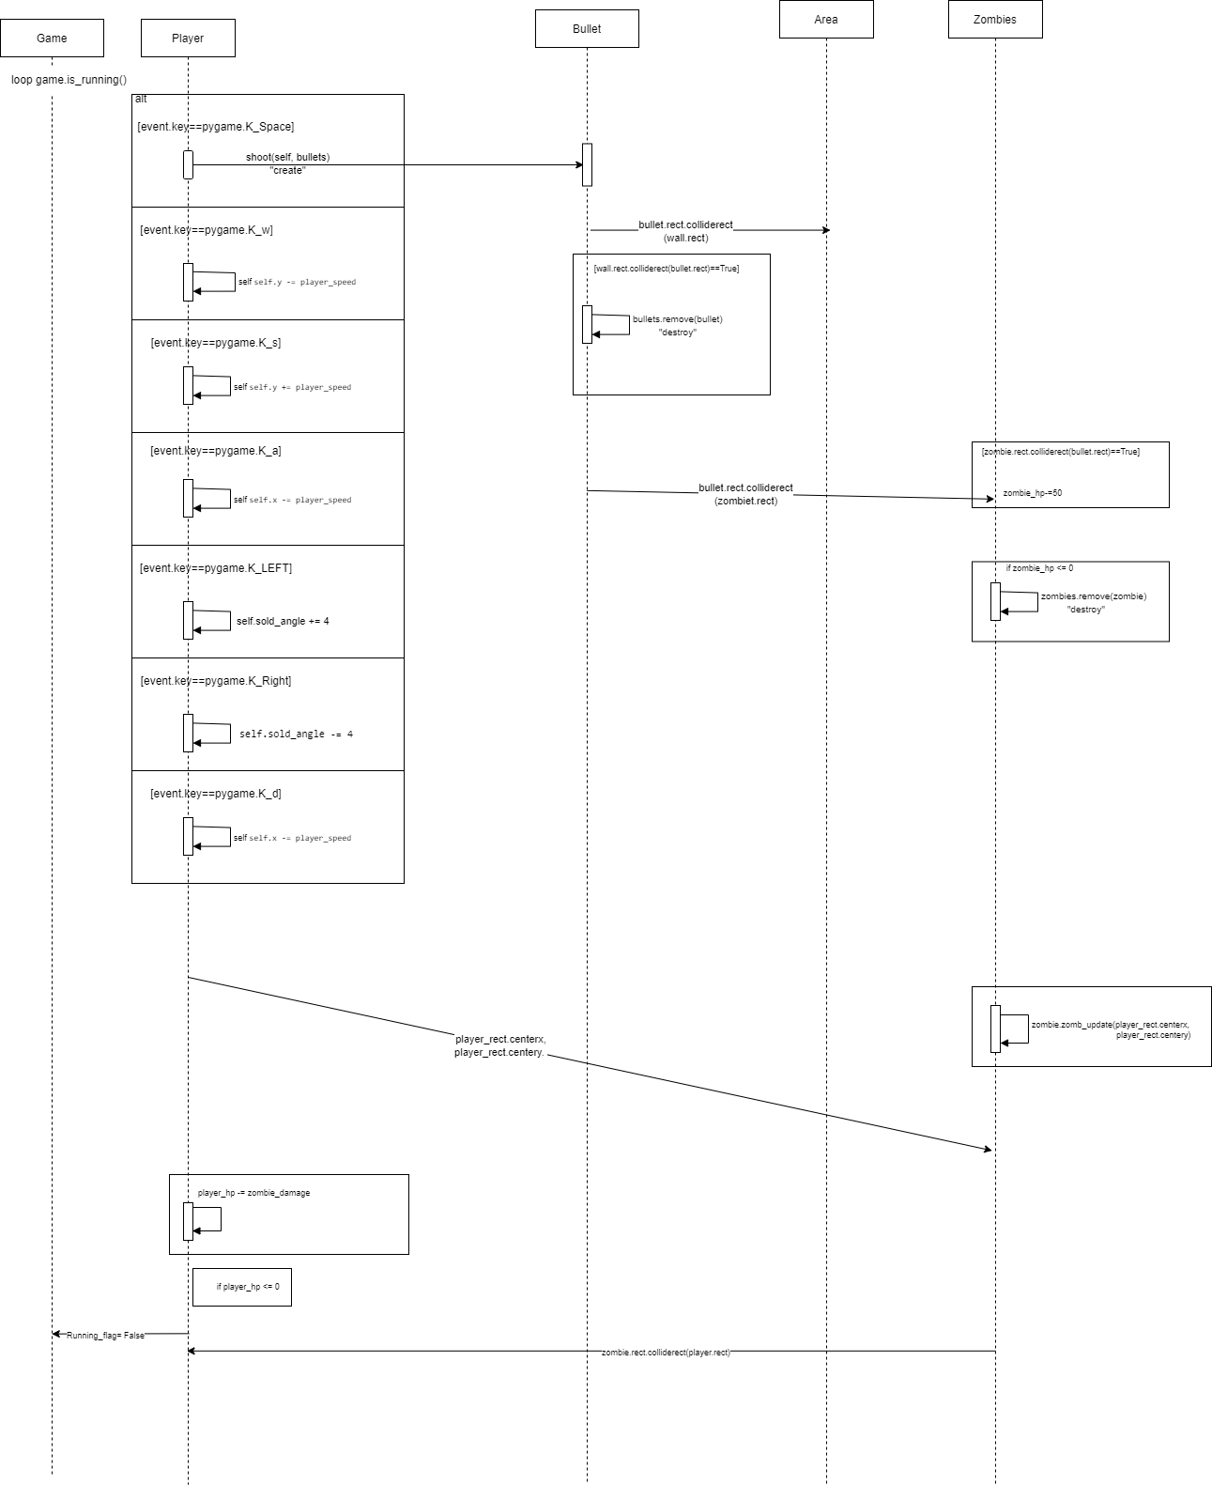

З матеріалами лабораторної роботи можна ознайомитись за посиланням: https://drive.google.com/drive/u/0/folders/1vK_b_SeLI8OxTEDzMlFa2WP_xeqomCmr

**Висновки:**

В цій лабораторній роботі я навчився створювати ігри з використанням бібліотеки pygame. Вивчив базові медоди роботи цієї бібліотеки та створив власну гру.